PROJECT ABSTRACT

Topic:Trust management system

**TRUST MANAGEMENT SYSTEM**

The project aims to automate the function of a trust and also keep the details of the members,donors,spnsors and employees of the trust.it also keep an updated account of transation done within the trust

**Admin**

Admin is the head of the trust.admin maintain the details of the trust.it also maintain the members of the trust and employees in the trust.it aso keep track of account details of receving the donation and expense details.it also keep the record of donors and sponsors ,and new admission and also take the people who ae brought by police or other people after investigation

**Donor**

Donors are people ready to donate fixed money at fixed time.They need to provide information like their occupation,adhar no,bank details,any other ID proof.After detailed investigation admin can add or reject or their request. Sponsers are people who would like to give education to a child or would like to take care of a person through out their lifetime.They must provide all details regarding them with valid ID proof.Admin can add or reject after detailed investigation.

**New admission**

Some people will not be willing to take care of their aged parent or ill children.They can give request to the admin.They can also give money to the trust for taking care of their parents or children.They are not considered as permanent donors as they give only money for the people who they admit.

**USECASE**

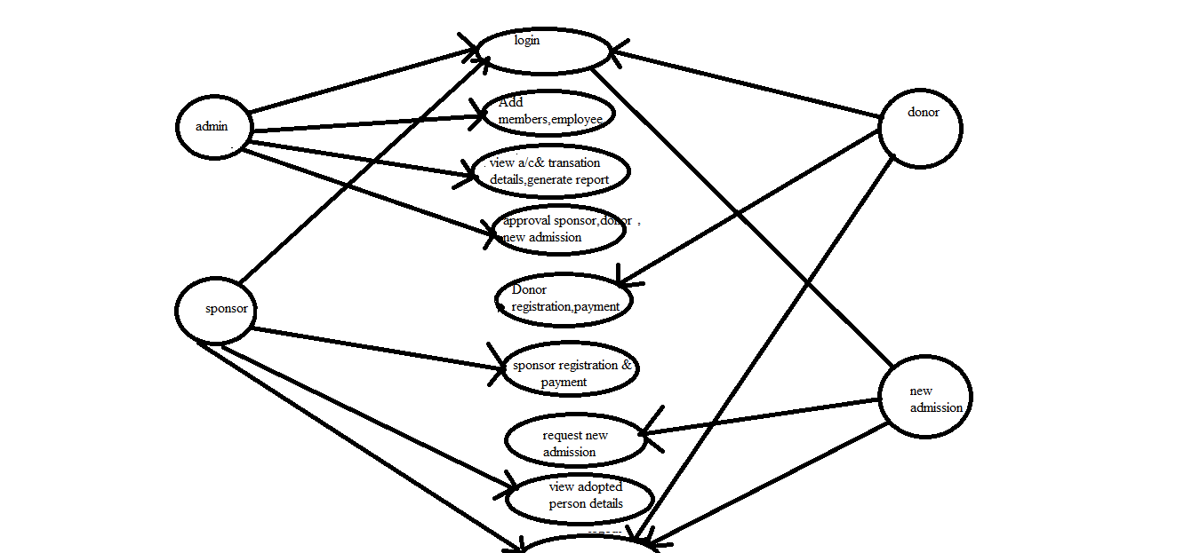

**DFD**

